DIRECTIONS TO THE ERIK BOHLIN’S OFFICE
Address: 9623 32nd ST SE, Suite A110, Lake Stevens, WA 98258
(GPS usually works)

Phone: 425-334-8916

From I-5
- From I-5 South or North, take exit #194 (Snohomish/Wenatchee Hwy 2).
- Take the LEFT-turning exit that says Lake Stevens / WA-204E.
- Stay RIGHT onto 20th ST SE ramp.
- Drive 1.5 miles to HWY 9
- Turn right onto State Highway
- Turn left onto 32nd St.
- There is a complex- Kids N Us, All Smiles Dentistry. We are the first building on the right. Buck Realty is just right of us.

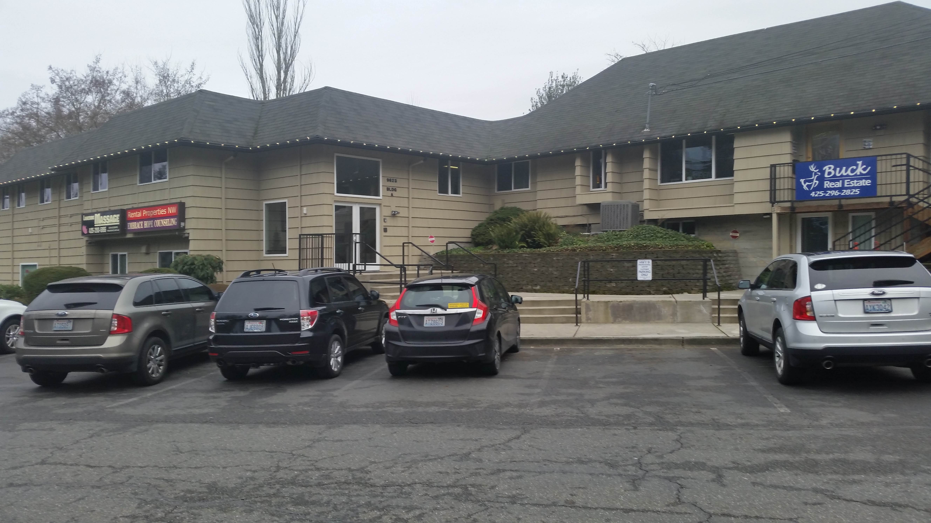

We are in the Professional Building A. Go up the stairs, inside the door and up the stairs again. We have 2 waiting rooms. You can wait in either of them. I will come out to greet you.

From Hwy 9 going North from Snohomish, Woodinville
- Drive North to 32nd ST SE.
- Take a right. We are in the Professional Building A next to Buck Realty

From Hwy 9 going South from Marysville, Arlington
- Go south on Hwy 9 till 32nd ST SE.
- Take a LEFT. We are in the Professional Building A next to Buck Realty.

